Project Design Phase Problem – Solution Fit Template

Date | 27 JUNE 2025
NM ID | 8050612605B5D909A0D43F9BC95E1D9A
Project Name | Garage Management system
Maximum Marks | 2 Marks

Problem – Solution Fit Template:
The Problem-Solution Fit simply means that you have found a problem with your customer and that the solution you have realized for it actually solves the customer’s problem. It helps entrepreneurs, marketers and corporate innovators identify behavioral patterns and recognize what would work and why

Purpose:
- Solve complex problems in a way that fits the state of your customers.
- Succeed faster and increase your solution adoption by tapping into existing mediums and channels of behavior.
- Sharpen your communication and marketing strategy with the right triggers and messaging.
- Increase touch-points with your company by finding the right problem-behavior fit and building trust by solving frequent annoyances, or urgent or costly problems.
- Understand the existing situation in order to improve it for your target group.

Template:

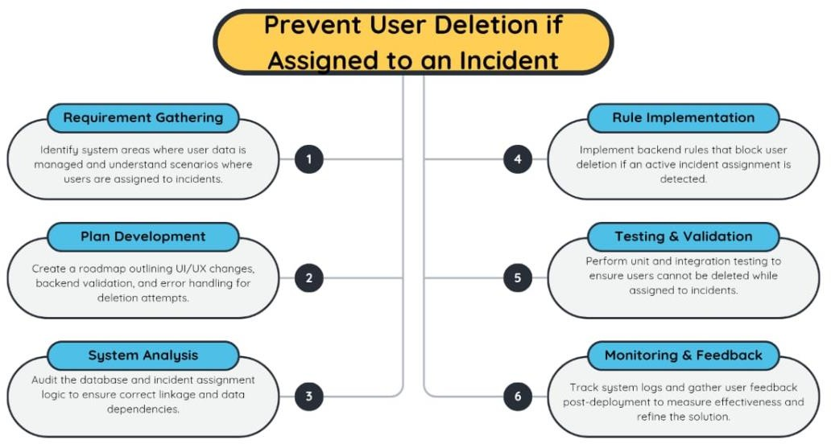

References:
- https://www.ideahackers.network/problem-solution-fit-canvas/
- https://medium.com/@epicantus/problem-solution-fit-canvas-aa3dd59cb4fe

The project "Prevent User Deletion if Assigned to an Incident" addresses a crucial gap in user and data management within incident tracking systems. By ensuring that no active user involved in an incident can be accidentally or unknowingly deleted, we significantly improve accountability, data integrity, and operational transparency. This solution not only safeguards incident resolution workflows but also supports better auditing and compliance. With the successful implementation of rule-based checks and continuous monitoring in platforms like ServiceNow, this project sets a foundation for building smarter and safer administrative systems in enterprise environments.

